84.06.26
From Frederick Bailey
RB MSS M5, Library, Royal Botanic Gardens Melbourne.

Government Botanist's Office Brisbane
June 26th 1884
Dear Baron Mueller
At Bowen Park this morning I saw a New Guinea Lycopodium, a form of L. varium? fruiting I therefore send you a specimen as it is much more slender in the leaf and with little or no difference between the lower leaves and the bracts you may find it a distinct species — I also send a very pretty orchid also a New Guinea plant, a Dendrobium of Section Aporum this has long racemes of pale streaked flowers which are most delicate in texture — this stem thickens above the thin base like that of D. tetragonum only with blunt angles see — It seems a free bloomer. I thought you would like these two plants so send them and I also wish you to have all material for working up the flora of New Guinea there are several other plants from New Guinea at Bowen Park but of some there is not sufficient to allow of my sending you specimens but if you like I would run you out a diagnosis of such. Now just going out of flower is a Sarcochilus or Cleisostoma I have not examined the flower with yellow small flowers the leaves about 2 or 3 in. long & raceme about the same length.
There is also a Dendrobium that was given to the society several years ago by one of the officers of the "Dido" in flower This species only differs from Dendrobium Taylori, in that the pedicels are bearded with white callosities I dont know the Island but it was said to have been got on one of the SS Islands

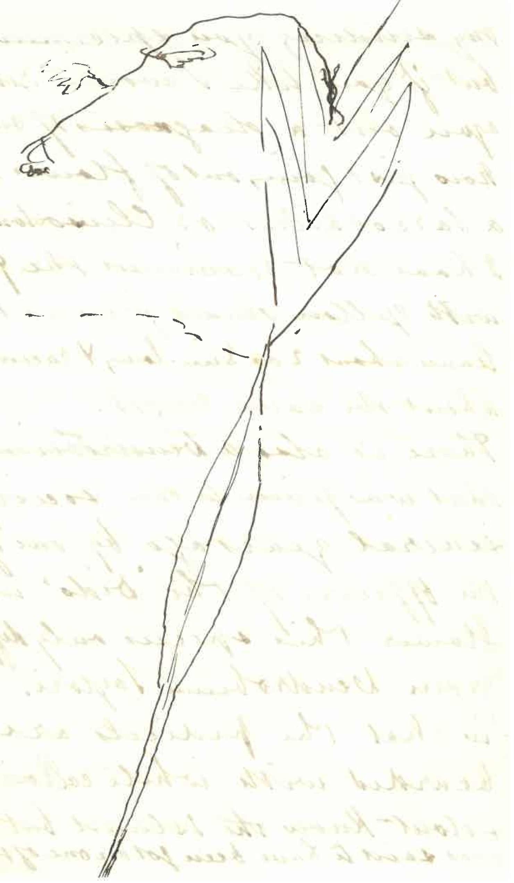

Cleisostoma
Dendrobium Taylori
Dendrobium tetragonum
Lycopodium varium
Sarcochilus

MS in Bailey’s hand, found with a specimen of Dendrobium macfarlanei (MEL 544735).
The Queensland Acclimatisation Society’s ground in Brisbane.
MS has a dotted line leading to the adjacent page which contains a whole page sketch of the plant: 84-06-26_image01.jpg
South Sea Islands. MS ends at bottom of page without valediction. There may be some text missing.

